Current exploration in the Junee-Florentine Area, Tasmania.
Jeff Butt
Introduction.
The Junee-Florentine area is located in and adjacent to the Western side of Mt. Field National Park in the Southwest of Tasmania. This area hosts the majority of the deepest and most sporting caves in Australia, including caves like Niggly Cave (375 m), Ice Tube (360 m); and long caves like the Growling Swallet (12 km) and the Threefortyone System (9 km).
The surface divide between the Florentine and Junee River catchments is breached by the subterranean drainage system. The major swallet is Growling Swallet in the Florentine catchment and the major resurgence is Junee Resurgence in the Junee catchment. The linear distance between these two features is 9.5 km. Caves holding the underground river are known for less than half this distance, there is a ‘gap’ of 5.5 km between the downstream end of Niggly Cave and the upstream end of Junee Cave and clearly there is plenty of potential for new discoveries. Indeed there is potentially a System 150 km long and 500 m deep in the Junee-Florentine.
Major Caves (solid lines) and Hydrological connections
(arrows) of the Junee-Florentine, from Eberhard (1994).

Initial Speleological investigations were started ~40 years ago as the area was logged. In the hey-days of the 1970’s many caves were found in quick succession, so attention kept wandering. This resulted in many caves not being explored as fully as perhaps they could have been. In addition, the original technology of using ladders made much of this original exploration of somewhat ‘epic’ proportions.
The work by Rolan Eberhard (1994) and (1996) summarises the state of exploration and knowledge of caves in the Junee-Florentine up to 1995 very well.

Recent Explorations
More recently a few keen members of the Southern Tasmanian Caverneers-STC (formed by an amalgamation of the Tasmanian Caverneering Club-TCC, the Southern Caving Society-SCS and the Tasmanian Cave and Karst Research Group-TCKRG in 1996) have been systematically working on small areas within the Junee Area. Systematic work is slow, but it does pay dividends. In every cave we’ve looked at we’ve found new passage, which we have surveyed as we have explored. Five years ago, our active group (then under the SCS banner) joined Rift Cave and Threefortyone Cave (both ~1 km in length) to create the Threefortyone System which is approximately 9 km long and 249 m deep. Exploration in the northwest of this system has taken us to within 200 m of Niagara Pot. After something like 40 trips to this system it was ‘time for a change’ of scenery, although there are still some leads remaining.

The main underground drain between the Growling Swallet and Junee Resurgence lies to the Southwest of all the known caves, and so we have been directing our attention to this region. This area was initially investigated ~30 years ago. One cave (Hairygoat Hole) with a very promising draught at the bottom was known but we have not been able to relocate this cave, despite many determined efforts. During our attempts to find Hairygoat Hole we did fine many new holes, most of little significance. One interesting hole, named Scratch Pot was in a very interesting region, right above where the main drain should lie, but it bottomed out at 80 m depth. We also relocated Splash Pot, a swallet a few hundred metres from Khazad Dum. Again Splash Pot was explored on ladders 30 years ago and surveyed to be ~100 m deep. At the bottom was some very tight stream-passage. In the 1980’s there were some trips to this cave and in 1987 Trevor Wailes and Rolan Eberhard pushed through the tight stuff, appropriately named “Close to the Bone” (CTTB) to a couple of small pitches. Rolan explored down below these, but his exploration was only cursory and no surveying was carried out. For those who might like to know, Close to the Bone is a torturous 50 m of stream-passage, it is generally about 20 cm wide, but has various 25 cm wide holes through which one has to pass. For the CTTB experienced it typically takes an hour to negotiate this obstacle and with packs of gear this is a particularly demanding piece of cave and definitely not for the claustrophobic.

Anyway, in our true systematic fashion we decided to survey Splash Pot, which was particularly hard work. But as we all know, hard work does generally pay dividends and below Close to the Bone we found about 2 km of new cave, including a “6 second” pitch. This pitch “Harrow the Marrow”, proved to be 113 m and is a beautiful 20 m diameter shaft. A waterfall down the middle occasionally gets blown by a strong breeze over any caver on the rope a few metres away. The nature of this breeze, which appears to originate from a window on the far side of the shaft, suggests that it connects to the “Master Cave”, but to date we have not been able to realise a connection. To access the window would be a major aid-climbing undertaking....and since all gear would have to be brought down through CTTB, this has not happened.

Our surveying efforts showed that we were heading towards Khazad Dum (KD), but there were problems with the KD survey data (collected in the early 1970’s). These problems were brought to light in 1998 during an overland survey between Khazad Dum and Dwarrowdelf, as outlined in Butt (1999). The revelation here was that KD was not 323 m deep (over the magic 1000’ mark), but only 275 m deep. So, we ‘bit the bullet’ and commenced a re-survey of KD. During this re-survey, new cave was found and it is likely that a connection to Dribblespit Swallet will be realised. Our surveying efforts showed that KD and Splash Pot were very close to each other in several places, but despite thorough exploring and surveying we have not been able to ‘close the gap’. Doing this is highly desirable as it means that CTTB would be able to be bypassed; this would make further exploration down the bottom of Splash Pot, including tackling the window in the side of Harrow the Marrow much more feasible.

Other small nearby caves, JF40 and JF69 were revisited and surveyed, again significant amounts of new cave were found (particularly in JF69). Currently Splash Pot is 306 m deep and 2.5 km long. Our survey data shows that we are ~10 m away from Khazad Dum and eventually one would imagine that we will link these caves to have a 6-7 km long system. Other caves such as Dribblespit Swallet, JF69 are also within 20 m of being added to the system.

Downstream, we are also within 80 m of Cauldron Pot and if a connection is made here, then we would have a System about 8-9 km long and 385 m deep, which would be the deepest cave in the country.
Detail of the major caves (solid lines) and hydrological connections (arrows) at the Junee ‘end’, from Eberhard (1994).

The Future:
We have some tidying up to do with the surveying in both Splash Pot and Khazad Dum (in particular the ‘Depths of Moria’). It is hoped that we may soon link KD and Splash Pot to allow easier access to the promising parts of Splash Pot.
Systematic work does pay dividends, and whilst much of the current caving is demanding and may appear to be boring surveying, we are achieving a good result. It is hoped that cavers in the future will be able to build upon our work without having to repeat it!
The biggest impediment to our work is finding enough keen cavers....so, if anyone out there is keen, please make contact, there are lots of interesting things to do!

The table below lists the current lengths and proximity of caves to each other.
Cave | Length (m) | Depth (m) | Notes
Khazad Dum | 3500 | 285 | ~10 m from Splash Pot
Splash Pot | 2500 | 306 | ~10 m from Khazad Dum
Dribblespit Swallet | 340 | 150 | ~20 m from Khazad Dum
JF40 | 160 | 40 | ~40 m from Splash Pot
JF69 | 180 | 28 | ~10 m from Khazad Dum
Troll Hole | 300 | 92 | ~ 60 m from Dwarrowdelf
Cauldron Pot | 1600 | 305 | ~80 m from Khazad Dum
Hypothetical System | 8600 | 385 | Yet to be realised, but we’re working on it!

References:
Butt J. (1999) “Khazad Dum: Setting the Depth Records Straight, 27 years on”, Australian
Caver 149, p 11-12.
Eberhard R. (1994) “Inventory and Management of the Junee River Karst System, Tasmania”
A report to Forestry Tasmania.
Eberhard R. (1996) “Inventory and Management of the Florentine Valley, Tasmania” A
report to Forestry Tasmania
HUNTING SIGNATURES
by Darryl McDowell

Go caving with a member of The Rover Speleological Society (RSS) and you will probably find yourself looking not at cave decorations, but at graffiti!

[Why is this so? Have the members of RSS finally succumbed to cave madness or were they always like this? It all started a long time ago, in a galaxy far, far away ....... Oops, sorry, wrong story]

It all started a number of years ago as a project of historical interest to identify people who visited Jenolan Caves - either local residents or early colonists and government officials who had the time and resources to organise expeditions to caves. The project has expanded to include possible links to other cave areas with anecdotal evidence of signatures of the same people in different cave areas.

RSS accepted the invitation of Ernst Holland to become involved in this project at Jenolan in 1994. The scope of the project includes surveying all the caves, with the exception of the tourist caves, at Jenolan for historically significant signatures and associated dates. The project was planned to take 10 years. Rob Whyte of UNSWSS is documenting the tourist cave signatures.

The identification of the early cavers is to be determined with the assistance of JCHAPS - The Jenolan Caves Historical And Preservation Society. The base reference document we are using is “The Caves of Jenolan 2: The Northern Limestone” edited by Bruce Welch 1976 (SUSS).

OK, so that’s the credits done - now lets get into the interesting part of the story: methodology - now don’t anyone get too excited! The methodology is quite simple - go caving, look for signatures, rejoice when you find some! - simple!

Obviously when we find a historically important signature the information needs to be recorded.

But first, what constitutes a “historically significant” signature? After some preliminary surveys, we decided that signatures or graffiti that date prior to 1965 are historically significant.

So, this begs the question - Are people born before 1965 historically significant or just old? Of course the other side of the coin is that maybe people born after 1965 are not significant! Now that I have insulted everyone in the room, let’s move on.

The information to be collected has three parts.

- Firstly, the cave location is updated on the field photocopy of the location map where there is an error or some confusion.

- Next, the signature location, within the cave, is marked on the cave map and numbered for reference.

- Finally, the details of the signature are recorded onto a project sheet similar to those shown.

These details include the cave name and number as per the book. Both are included for ease of reference. Some people know caves by name, others by number.

The location reference number as marked on the cave map is recorded. The height above the floor is marked and the surface that the signature is on is recorded - for example: wall, shawl, stalagmite.

This results in the marked map and information sheet being needed to locate the signature at a later time. This provides an effective method to revisit signatures whilst affording some level of security.

The material and method used to create the signature are next recorded. Common materials and methods are charcoal, pencil, carbide soot, and scratched into the surface. This is extremely useful in ascertaining the most likely date that a signature was created especially when an abbreviated date is used. For example, a signature may include a date of 7/3/54 which could refer to either 1854 or 1954.

[And you thought the Y2K bug was a problem!]

The material and method used also assist in the authentication of dated signatures.

One of the problems in hunting signatures is being able to read what is actually written when a signature is faded or damaged, which often happens to charcoal and pencil graffiti. This can include looking from various angles and lighting from various directions and with different lights. All this is done with as many pairs of eyes as possible looking to decipher the subject signature.

Next item recorded is the surveyors interpretation, or best guess, as to what is written. This will be used for subsequent spreadsheet entry.

A copy of the exact details of the signature is made including gaps and all marks. This is a sketch of the signature and we particularly look for style of writing in order to date signatures and authenticate dated signatures.

Lastly, the trip details and those surveying are recorded. This is to assist with later clarifications of the data if needed.

So that’s the methodology. But what have learned so far?

The project is definitely a long term one as correlation of the data using a spreadsheet is yet to be done. The physical surveying is a long process especially as it is being done on a voluntary basis. There are however a number of interesting facts that we have discovered so far which we would like to share with you.

A fascinating effect of this project on the behaviour of members of the society is that when we are exploring caves we are likely to observe signatures far more readily than you would otherwise expect - you might say we have become graffiti aware.

One example of this was a visit to Glass Cave at Jenolan which was an exploratory, or recreational visit. The trip very quickly turned into a signature gathering one when a whole wall of signatures was discovered. So absorbed were the party members that they showed little interest in assisting one member who was having difficulty in descending from a climb he had undertaken.

There are various reasons for placing signatures. Some are just to record the fact of visitation by the person. These signatures are often in places where they become covered or damaged as little thought is put into the location.

Some signatures record discovery such as those of Wyburd and Wilson. Such signatures are in a prominent location but usually well placed to avoid damage.

Then there are signatures from people such as the infamous G.Taylor who generally climbed to the highest point of the highest aven, and then precariously balanced whilst placing his signature to record his achievement.

Sometimes copycatting occurs at locations where one person includes their address and then subsequent signatures also include their address.

One amusing example of a signature at Jenolan is of a honeymooning couple who placed their initials - she at first incorrectly, having to cross out and change her last initial which had only recently changed!

Signatures in protected areas within the caves are incredibly well preserved to the point that the small chips from the lead of a pencil are still present on such signatures.

Sometimes signatures reveal just how accessible some caves were in years past, before we learned the importance of preserving them and limiting access.

Some of the interesting signatures and background that we have discovered include the beginning of Brett Whiteley’s artistic career at 9 years of age at Jenolan. This particular piece of graffiti also includes his parents’ signatures.

In Carey’s Cave at Wee Jasper, the signatures have been correlated to local residents using the school records. Interestingly, some of the signatures here are being covered over by new calcite growth.

The signatures found in Swallow Cave at Cudgegong appear to belong to local families, on initial investigation.

At Wellington, miners of phosphate during the war left their mark along with overseas visitors who were collecting samples.

The famous Wyburd, Edwards and Wyburd signatures that appear in numerous caves at Jenolan can also be found at Tuglow Caves.

So where are we going from here? Other than the continuation of collection of data from the field, the information will be correlated into a database allowing it to be sorted and compared by location, date, person and initials. This will enable further authentication and identification. We will then be looking for any other interesting or revealing information to assist with the identification of the early visitors to the caves.
The project has the capacity to extend to all cave areas with the possibility of revealing many interesting facts about early cave exploration.

So next time you see a signature in a cave - record the details and send it to us at RSS ---- Happy Hunting!!

JENOLAN CAVES
STATE OF THE ENVIRONMENT REPORT

Andy Spate

Chair: Social & Environmental Monitoring Committee

Introduction

This is a summary of a powerpoint presentation. The original slides are shown on the CD version of these proceedings.

This report discusses the following:

What is the Social and Environmental Monitoring (SEM) Committee and why is it there?

Who is involved?

What has SEM done?

The social environment

The surface environment

The cave environment

“Show” caves

“Wild” caves

Where to from here?

What is SEM & why is it there?

The Social and Environmental Monitoring (SEM) Committee was formed in 1996 to provide independent expert advice to the Trust on the State of the Environment at Jenolan.

TERMS OF REFERENCE

The Committee should provide independent advice to the Jenolan Caves Reserve Trust on the State of the Environment and the Visitor Impact Monitoring Program. This advice may include budgetary recommendations.

The Committee will prepare an annual State of the Environment Report in conjunction with the Karst Resources Manager.

The Committee will make recommendations to the Trust and guide the Karst Resources Manager on all matters relating to the Social and Environmental Monitoring program including:

Monitoring protocols

What to monitor

Methods and equipment

Personnel and resources

Analysis of data (information)

Any other relevant matters

WHO IS INVOLVED?

Chairman: Andy Spate, NSW National Parks and Wildlife Service, Queanbeyan

Prof Elery Hamilton-Smith, Rethink Consulting, Melbourne (former Chairman)

Bruce Gall, Environmental Consultant, Canberra

Prof David Gillieson, James Cook University, Cairns

Dr Grant Hose, NSW Dept of Land and Water Conservation, Sydney

Dr Neil Lipscombe, Charles Sturt University

Dr Ruth Lyons, University of Auckland, New Zealand

Peter Valentine, James Cook University, Townsville

David Smith, Wombeyan Caves, Staff Representative

Dr Julia James (now retired from SEM)

WHAT HAS SEM DONE?

Publications/reports

Table of SEM Achievements to December 1999. (Thurgate & Hamilton-Smith, 2000)

Two State of the Environment Reports included in the Trust’s Annual Report, one “in press”

An Environmental Risk Management Assessment for Jenolan Caves Reserve (Gall, 2000)

The Social and Environmental Monitoring Program at Jenolan Caves (Hamilton-Smith and Ramsay, 1998). (nomination to the Australasian Evaluation Society 1998 Awards for Public Sector Evaluation - Received a Certificate of Commendation for Methodology in Public Sector Evaluation)

SEM Information Sheets

Assistance to Karst Resources Department with Karst Out

Workshops

Environmental Risk Assessment/Threatening Process Identification workshops (3)

SEM Review Workshop (May 1999)

Key Environmental Indicators

Large array of indicators established by Manidis Roberts 1995 Report

Further indicators have been investigated by SEM especially through:

the Risk Management Assessment Report

State of Environment Reports

working papers and research proposals

Some indicators have been investigated and found to be not of concern

Advice on many matters

THE SOCIAL ENVIRONMENT

Issues investigated include:

Visitor experiences

Visitor attitudes

Demographics

Dissatisfaction factors

Crowding

lack of support for non-English speakers

food

other visitor services

lack of information on surface activities (and perhaps such activities generally)

More studies/surveys to come

SPIRT grant - PhD project

VALUES, RISKS, HAZARDS AND THREATENING PROCESSES

Flora and fauna studies

bats, cave and aquatic invertebrates, flora

Risk assessment

Surface infrastructure

track upgrades

interpretation

Mapping and land classification studies

Weeds and ferals

Water quantity and quality

physical and chemical parameters

AusRivas

microbiology

THE SURFACE ENVIRONMENT

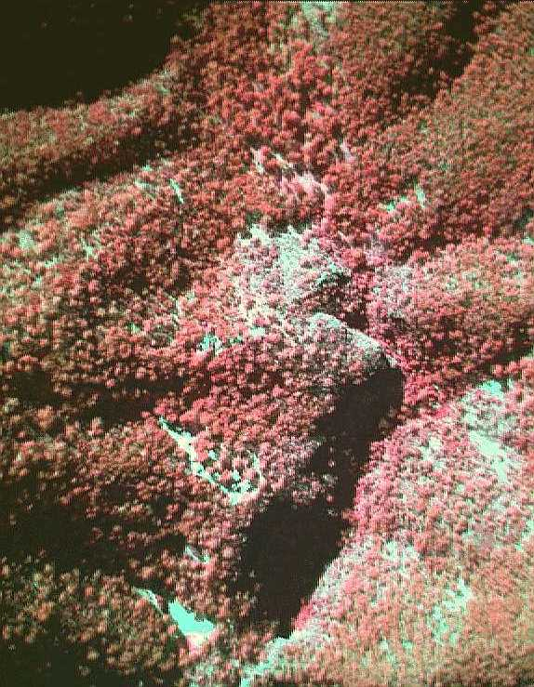
Airborne multispectral video image of the area from Number 2 Carpark to Playing Fields area. Higher intensities of red indicate healthy eucalypt canopies. Original image resolution is one metre.

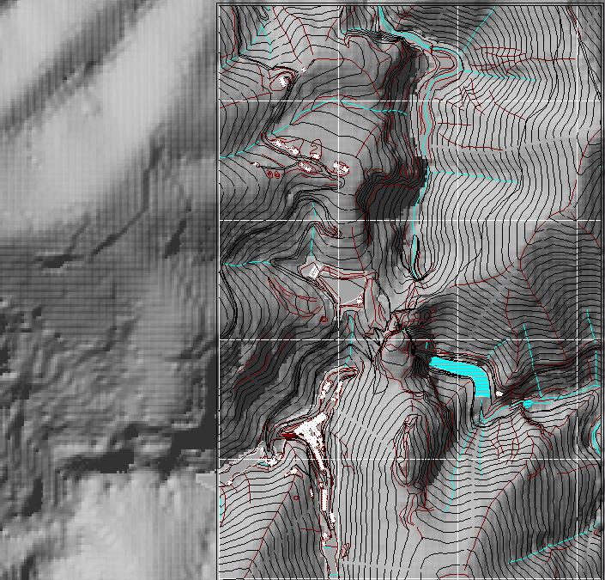

Section of the detailed 5 metre Digital Elevation Model for Jenolan Cave with partly overlain infrastructure. Synthetic hillshading model used to simulate afternoon light.

THE CAVE ENVIRONMENT

“Show” caves

Dust/lint

Radon

Carbon dioxide

Temperature and humidity changes

Hydrocarbons

Other pollutants

Hydrologic issues

Surface/subsurface interactions

Cave infrastructure

Cave maintenance including cleaning

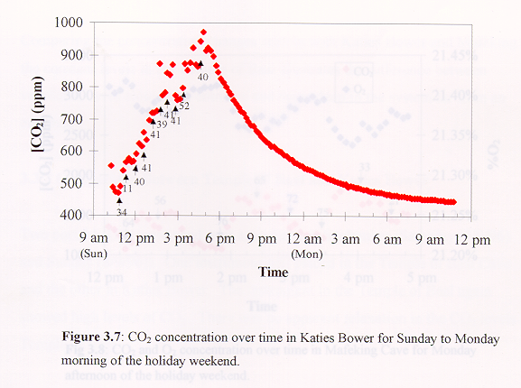

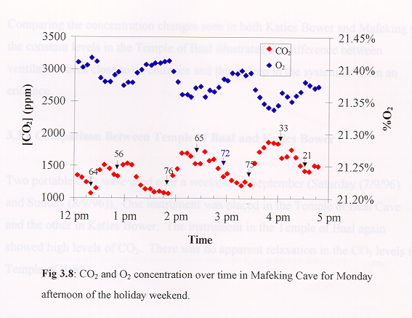

Carbon dioxide and tourist visits: June long weekend 1996 (Cooper 1996)

THE CAVE ENVIRONMENT

“Wild” caves

SEM does not have a good handle on these issues! Nor does it necessarily have the expertise?

ASF member societies might like to take a role?

Issues include:

Adventure tour pressures?

Organised speleological pressures?

Above and below water impacts of cave divers?

Potential physical issues such as digging, bolting, track marking?

Social interactions?

Other issues?

ARE THE WILD CAVES BEING ADVERSELY IMPACTED?

If so what can and should be done?

What are appropriate indicators?

WHERE TO FROM HERE?

ISSUES CONFRONTING SEM:

Maintenance of enthusiasm

Getting to grips with the wild caves

Relationships with Scientific & Speleological Committees

Interactions with a wide range of stakeholders

Communication

Information flow

Feedback

State of Environment Report

Replacement of Karst Resources Officer

Replacement of Dr Julia James

Strategic Plan for SEM

Do we need a new Plan of Management for Jenolan? YES

SEM believes that this is well overdue

SEM will be pushing for this to be done

Why?

New legislation and administrative arrangements in place for some time

Old plan considerably out of date

Many issues better understood

Community attitudes may have changed

The ways in which Jenolan is used have changed

SEM hopes for substantive, constructive input from the organised caving community

However, it will not be a SEM-based process.

